WHY WASHINGTON SHOULD JOIN THE
ZERO EMISSION VEHICLE (ZEV) PROGRAM

WHAT IS A ZEV?
The term Zero Emission Vehicle – or ZEV – refers to vehicles that are capable of operating with no tailpipe pollution. There are different types of ZEVs including pure battery-electric vehicles (EVs) (e.g. Nissan Leaf), plug-in hybrid electric vehicles (e.g. Chevy Volt) and hydrogen fuel cell electric vehicles (e.g. Toyota Mirai). Widespread adoption of ZEVs reduces carbon and air pollution and lowers fuel costs for consumers.
Hyundai Kona EV SUV (Not available in WA, only available in ZEV states)
available in ZEV states)

WHAT IS THE ZEV PROGRAM?
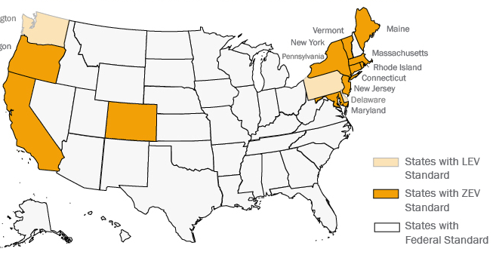
California’s ZEV Program requires automakers to sell a minimum percentage of ZEVs within a state or pay a penalty. It mandates that a minimum of about 3% of all cars sold by an automaker in 2019 be ZEVs, rising to a minimum of about 8% by 2025. Other states are allowed to adopt California’s standards, and ten states have taken this option. (Minnesota and New Mexico are in the process of joining, which will bump the total to 12.)

WHERE DOES WASHINGTON STATE STAND WITH THE ZEV PROGRAM?
Under pressure from automakers, Washington State passed a law in 2005 preventing the state from joining the ZEV program. In 2019, Sen Joe Nguyen (D-34th) introduced SB 5811, a bill to repeal this prohibition and allow Washington to join the ZEV program. The bill passed the Senate in 2019, but stalled in the House Energy and Environment Committee. Gov. Inslee strongly supports the bill.
Sen. Nguyen
WHAT ARE BENEFITS OF BRINGING THE ZEV PROGRAM TO WASHINGTON?
For Consumers
ZEV incentivizes automakers to make their full range of EVs available in ZEV states. For instance, the Hyundai Kona, an electric SUV with 258 miles of range with list price of $36,900 before incentives, is only available in ZEV states. EV prices also tend to be lower in ZEV states, because automakers incentivize their sale and lease.
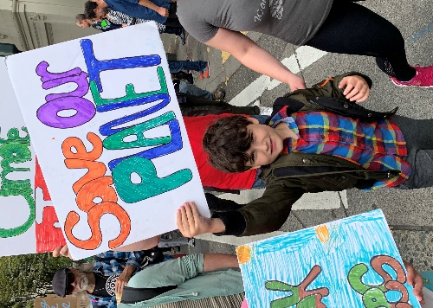
For the Climate
Gasoline cars are the single biggest source of carbon pollution in Washington, and account for about 40% of the carbon pollution generated by families. To make the big cuts in carbon we need, we must make the transition from fossil fuel cars to cleaner alternatives. We also show the Trump Administration that Washington stands with the ZEV states working to reduce carbon pollution from vehicles.
For Jobs and the Economy
Washington sends more than $6 billion out of state every year for gasoline. If Washington cars convert to electric, that money can be kept in state to create jobs and economic development.
The following organizations support passage of SB 5811: Coltura, Climate Solutions, Sierra Club, Union of Concerned Scientists, NRDC, Audubon, Consumer Reports, National Clean Car Coalition, Puget Sound Clean Air Agency, Front and Centered, 350 Seattle, Stand.Earth, Environment Washington, Carbon Washington, Seattle Electric Vehicle Association, Plug In America, Drive Electric Washington, NW Energy Coalition, Tesla, Washington Democrats Climate Caucus.
For more information, visit www.coltura.org, email mnm@coltura.org, or tel. 206-445-7628

