SB 5280: Community Solar Gardens
Olympia Community Solar
Olympia Community Solar is a Washington State non-profit corporation that provides education, development, and administrative services for community solar systems.

We encourage your continued support of the SB 5280 and ask that you work with Chair Carlyle to schedule a hearing in the Energy, Environment, and Technology Committee so it may progress toward the Governor’s signature. We see this bill as a critical piece to progress community solar in Washington State.

Washington State has shown strong interest in the development of community solar installations, with over 70 operating and 23 recently approved by the WSU Energy Extension for construction in the next year. However, WSU is no longer accepting incentive applications for community solar, halting further developments pending a legislative fix. This bill will allow our industry to grow outside the production incentive program and provide clarity and definition to our state market.

Effective, affordable, and accessible renewable energy deployment is key to achieving the emission reduction goals outlined by Governor Inslee, the IPCC, and others while simultaneously improving the reliability of our energy grid. We see community solar gardens as a crucial component of an effective deployment strategy, as it will allow many communities to make direct investments in renewables for the first time.

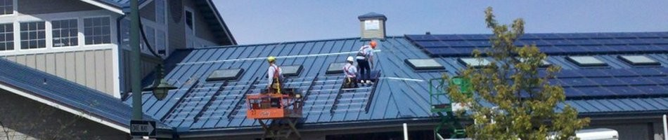
37 kW Community Solar Array, Olympia Farmers Market. Installed in 2012 by Sunset Air Inc.

Overall, we are in strongly in favor of this bill in its original form, and we have some suggestions to make it a leading state program. We support tying the credit rate for community solar to the existing retail rate (3.3B). This is a fair practice and will allow for rate flexibility as the energy market changes. The capacity carve outs for residential and commercial customers (3.1D) are consistent with many other states around the country - ensuring small customer participation and that systems actually are “community” owned.

Current Language | Our Suggestion | Reasoning
Section 3.1B  A community solar array must be fully subscribed | Include a qualifier as to when a system must be subscribed (e.g. certification or interconnection) | A single subscriber issue would lead to project delays and expecting full subscription for the system lifetime is unrealistic.
Section 3.1C “If the electric utility’s plan identifies preferred locations... preferred location.” | Remove | Existing limitations on interconnection will force projects into conducive areas without this section. These systems are extremely dynamic and scalable and should be located where they are most useful.
Section 3.1E  “Must allocate not less than ten percent of project capacity to low-income customers.” | Use program capacity rather than project capacity. Support low income participation | See best practices in CO and OR policies. They each have a 5-10% low income allocation program wide.  Washington should expand LMI incentives to increase participation levels.
Section 4.3 - Missing | “Provide for the purchase of unsubscribed energy at a commission approved rate or avoided cost to the utility” | Gardens have every incentive to remain fully subscribed, but minimal subscription turnover is expected in any organization.  Similar to the production incentive, credits that are not allocated during a billing period could be held at the host meter. These credits are then available, along with new credits, in the next distribution period. New subscribers may be allocated credits that were accrued prior to their subscription start date.
Section 4.3 - Missing | “Electric Companies shall remove subscribers who are canceling participation and add new subscribers to the project within one billing period, as requested by a Subscriber Organization. | Allowing for subscription transferability (allowing subscriptions to be transferred between or to new members) will increase subscription and retention rates. It will also help subscriber organizations maintain fully subscribed projects.

